**An Adaptive Hybrid Beamforming Approach for 5G-MIMO mmWave Wireless Cellular Networks**

**Abstract**

The architecture and deployment of next-generation broadband wireless networks revolve around the principle of hardware complexity reduction. In order to do this, the work described in this article sets out to assess the effectiveness of an adaptive hybrid analog-digital beamforming method in fifth-generation (5G) MIMO mmWave wireless cellular systems. In this scenario, produced beams are formed dynamically in accordance with traffic conditions, through an analog on-off excitation of radiating elements per vertical antenna array, to serve active users requesting high data rate assistance without necessitating any costly and mechanically complicated steering antenna system. A specific radio frequency chain is present in each vertical array, which is a radiating component of a circular array design (digital part). A designed system-level simulator that incorporates the most recent 5G-3GPP channel model is used to run a significant number of independent Monte Carlo simulations for each MIMO configuration in order to statistically evaluate the performance of our proposed strategy. A number of key performance indicators (KPIs) of the wireless orientation, including total downlink transmission power and blocking probability, may be improved by the adaptive beamforming technique, according to the results that have been given. In particular, the proposed adaptive algorithm can significantly reduce the number of active radiating antenna elements compared to the static grid of beams case when studying/analyzing a MIMO configuration with 15 vertical antenna arrays and 10 radiating elements per array, depending on the acceptable amount of transmission overhead. The overall downlink transmission power as well as the likelihood of blockage can both be greatly decreased in the same situation when the number of radiating devices remains constant. It is crucial to keep in mind that all KPIs have been retrieved while implementing the generated array configuration in intricate cellular orientations (two tiers of cells around the central cell).

**Keywords:** 5G, hybrid beamforming, massive MIMO, millimeter wave communications, system-level simulations.

**CHAPTER-I**

**INTRODUCTION**

The provision of zero latency high data rate services to mobile consumers is intrinsically linked with a comprehensive network redesign as the deployment of fifth-generation (5G) broadband wireless cellular networks approaches reality [1]. In this regard, several cutting-edge technologies have been launched to serve the 5G vision, including massive multiple input multiple output (MIMO) designs [6]–[7], non-orthogonal multiple access (NOMA), and millimeter wave (mmWave) transmission. In the latter scenario, several antenna arrays are installed at cellular orientation base stations (BSs) to serve mobile stations (MSs) that are requiring high data rate services. The creation of highly directed beams that reduce multiple access interference allows for this (MAI).

Along with fifth-generation (5G) networks, the sixth-generation (6G) age of technology is on the horizon and is expected to link everyone and everything [8]. For multi-gigabit-per-second data throughput applications (i.e., 20 Gbps for downlink and 10 Gbps for uplink with latencies on the order of 1ms [9]) to be enabled, the required 5G equipment to be converted to high frequency devices. It will be necessary for ultra-small communication devices to support these kinds of bandwidth-hungry operations [10]. The future of 6G communications will thus be illuminated by the experience of the unique design and effective operation of mmWave antenna configurations in 5G communication technologies. The use of mmWave antennas in cellular systems can result in the design of powerful BSs in terms of flexible geometry and construction costs, it should be highlighted at this point. A multiplicity of adaptable BS installations are also made possible by the tiny size of mmWave antenna topologies, supporting changeable traffic and enhancing throughput overall.

Fully digital (FD) precoding is the standard method for adjusting the transmission power in conventional multi-user (MU) MIMO systems. In order to get the best beamforming, the transmitted signals' amplitudes and phases. However, since the number of radio frequency (RF) chains is equal to the number of antennas in a huge MIMO arrangement, using the FD technique would result in a considerable computational and hardware overhead. Since the hybrid beamforming (HBF) approach combines the analog precoder in the RF domain with the digital precoder at baseband, the majority of related research in this area focuses on suboptimal beamforming algorithms based on this technique. Consequently, fewer RF chains are needed for implementation as a result of the low-dimensional digital precoder. Using massive MIMO mmWave multicellular orientations, the performance of a low-complexity HBF structure is assessed in this research.

A thorough overview of hybrid multiple-antenna transceivers is given in [11], where the complexity of hardware architectures is identified as well as the needs for Channel State Information (CSI) are examined. In a similar vein, [12] presents a number of HBF structure suggestions for mmWave systems, concentrating on hardware, spectral, and computational efficiency as three important factors. According to the study that has been provided, an HBF can approach the FD one's performance with a proper structure and with relatively simple hardware.

The authors show that in the same situation, a minimal number of fixed phased shifters per transmitting antenna and an RF chain count proportional to the number of broadcast data streams are adequate. Various channel types and hardware configurations can be used using the framework for hybrid precoder and combiner design that has been provided in [13]. The huge MIMO systems used in 5G cellular communications can directly benefit from this approach.

In [14], a novel analog beamforming architecture is put out that relies solely on straightforward analog switches to provide beamforming benefits, in an effort to further minimize hardware and computational complexity. The suggested method claims that it is possible to attain both the complete diversity benefit and the entire array gain. Results are nonetheless restricted to a point-to-point transmission scenario with a single data stream. For a transceiver that combines hybrid analog-digital precoding in mmWave MIMO systems, the authors of [15] have developed a discrete Fourier transform (DFT)-aided user clustering hybrid precoding technique. To that purpose, the terms fully connected (FC) and partially connected (PC) are used to characterize two potential hybrid architectural structures (PC). As opposed to the second scenario, where only specified subsets of transmit antennas are connected to each RF chain, all RF chains are connected to each antenna element in the first scenario.

The FC construction provides better energy efficiency, according to the results, when only a few RF chains are used; otherwise, the PC structure is superior. [16] presents a low-complexity, power-efficient transmitter based on a two layer construction integrating azimuthal spatial directivity and information. The suggested transmitter can achieve comparable performance to traditional beamforming transmitters, according to the data that have been provided. The performance of hybrid analog-digital beamforming may be proven to approach that of FD beamforming in [17] while needing less complexity. In order to increase the possible spectral efficiency, an HBF strategy is provided in [18] that makes use of machine learning techniques (SE). To this purpose, the suggested two-step method can reach efficiency that is virtually as high as that of FD designs.

Other research focuses on the improvement of the MU beamforming and takes a specific HBF technique into account. In this regard, [19] considers an HBF design for systems using large-scale antenna arrays and orthogonal frequency-division multiplexing (OFDM). The presented results demonstrate that the FC architecture can achieve FD beamforming performance with a manageable number of RF chains, as also demonstrated in [12]. For the MU mmWave massive MIMO system, a deep neural network-based hybrid beamforming is proposed in [20] while taking into account a PC scheme.

This system is designed as an autoencoder neural network that is self-supervised from start to finish during training. The suggested methodology exceeds existing methods in terms of bit error rate (BER) performance by about 2 dB when taking into account a single-cell situation, according to simulation data.

For the uplink of huge MIMO mmWave heterogeneous network systems, the authors of [21] provide low-feedback overhead hybrid analog-digital precoder and equalizer techniques. The outcomes demonstrated that the performance of the suggested schemes is somewhat comparable to its FD counterpart. [22] discusses a single cell downlink MU massive MIMO system that uses a hybrid structure to allow many streams per MS while operating in a general channel model.

In an effort to prevent information loss at each level, the suggested technique develops the analog and digital stages in tandem. The developed approach is proven to outperform the state-of-the-art for HBF systems, even when the number of BS antennas is not particularly great, and it has the fewest RF chains. For a mmWave downlink MU system, an HBF technique with dynamic subarrays and low-resolution phase shifters is described in [23]. A straightforward heuristic design technique for a hybrid beamformer is also described in an effort to further minimize the complexity of beamforming. For MU MIMO-OFDM systems, an extension of the aforementioned work is described in [24].

The suggested hybrid beamformer algorithm in this situation tries to maximize SE and minimize mean square error. A two-stage HBF design strategy handling both SE and energy efficiency (EE) maximization is looked at in [25] when a MU MIMO downlink system is taken into consideration. To do this, the analog beamforming components are updated in the first stage; these updates are then taken into consideration when designing the digital beamforming components in the second stage to optimize the system's EE or SE.

Further considerations include hardware limitations and actual circuitry power consumption. The findings shown indicate that, in some multiuser settings, the PC technique performs worse in terms of SE and EE than the FD approach. The design of effective, low-complexity HBF techniques also takes interference mitigation into account. For the formulation of dynamic subarrays in massive MIMO systems, a hybrid MU framework is provided in [26]. According to the findings of the simulation, the dynamic subarray design greatly outperforms the fixed subarray architectures in terms of sum rate and expected error (EE).

A hybrid MU equalizer for the uplink of SC-FDMA systems using dynamic subarray antennas was developed and tested in [27]. These systems use broadband mm Wave massive MIMO. The suggested strategy may reduce MU interference, according to the results, and achieve BER performance that is very comparable to the FC approaches.

In [28], an interference-aware pre-beam former (analog beam former) design for joint spatial division and multiplexing is presented, which is a user-grouping based two-stage beamforming method. To this end, single-carrier frequency domain equalization (SC-FDE) is employed in uplink frequency-selective channels. According to the presented results, most of the interference is suppressed with the help of the proposed constrained beam formers. In the same context, an iterative block decision feedback equalization (IB-DFE) method based on minimum mean square error criterion is proposed for the digital beamforming stage.

**CHAPTER-II**

**LITERATURE REVIEW**

**Y. Xu, G. Gui, H. Gacanin and F. Adachi, “A survey on resource allocation for 5G heterogeneous networks: Current research, future trends, and challenges,” IEEE Commun. Surv. Tutor., vol. 23, no. 2, pp. 668-695, Secondquarter 2021.**

Different service needs of diverse communication contexts are anticipated to be met by the fifth-generation (5G) mobile communication system. Heterogeneous network (HetNet) has been researched recently as a novel evolution network structure. HetNets, which evolve tiny cells into the coverage of macrocells, might increase the possibility of geographic resource reuse and improve users' quality of service in comparison to homogenous networks. However, effective resource allocation (RA) algorithms are crucial to reducing the mutual interference and achieving spectrum sharing in HetNets due to the mutual interference between various users and the restricted spectrum resource. The RA in HetNets for 5G communications is thoroughly surveyed in this article. With regard to HetNets, we first define it and describe various network scenarios. It is then discussed RA models. In order to analyze the current RA algorithms for the works already in existence, we then present a classification. The last discussion touches on several difficult problems and potential research directions. As a result, we offer two potential structures for 6G communications, a learning-based RA structure and a control-based RA structure, to address the RA issues of the next-generation HetNets. The purpose of this article is to present key information on HetNets that may help direct the creation of more effective research methods.

**A. N. Uwaechia and N. M. Mahyuddin, “A comprehensive survey on millimeter wave communications for fifth-generation wireless networks: Feasibility and challenges,” IEEE Access, vol. 8, pp. 62367-62414, Mar. 2020.**

The underused, high-bandwidth millimeter-wave (mmWave) frequency spectrum, which has the potential for high-capacity wireless transmission of several gigabits per second (Gbps) data rates, is where fifth-generation (5G) cellular networks will almost definitely operate. Although mmWave signal transmissions have a huge potential for accessible bandwidth, they are plagued by fundamental technological problems because of their short wavelengths, including substantial route loss, susceptibility to obstruction, directivity, and small beamwidth. Accurate channel modeling that takes into account various 5G technologies and scenarios is crucial to supporting system design and deployment properly. This survey offers a thorough overview of several cutting-edge technologies for 5G systems, including cell-free massive MIMO, simultaneous wireless information and power transfer (SWIPT), hybrid analog-digital precoding and combining, massive multiple-input multiple-output (MIMO), multiple access, and NOMA. These innovations provide distinctive propagation traits and set particular standards for 5G channel modeling. To address these difficulties, we first evaluate the available standards and solutions, talk about the radio-frequency (RF) spectrum and regulatory concerns for mmWave communications.

Second, we contrasted mmWave communications with benefits such as narrow beam, excellent signal quality, big capacity data transfer, and great detection potential with existing wireless communication systems including sub-6 GHz WiFi and sub-6 GHz 4G LTE. Third, we discuss the mmWave band's basic propagation characteristics and review the available channel models for mmWave communications. Fourth, using system models of hybrid precoding architectures, hybrid analog and digital precoding/combining matrices, alternative antenna configuration scenarios, and mmWave channel estimation (CE) approaches, we follow the development and advancement of hybrid beamforming for massive MIMO systems.

Fifth, we broaden the debate to include multiple access approaches for mmWave systems with constrained RF chains at the base station, such as non-orthogonal multiple access (NOMA) and space-division multiple access (SDMA). In order to achieve spectrally and energy-efficient communications, we study the integration of SWIPT in mmWave massive MIMO systems with constrained RF chains.

**A. V. Lopez, A. Chervyakov, G. Chance, S. Verma and Y. Tang, “Opportunities and challenges of mmWave NR,” IEEE Wirel. Commun., vol. 26, no. 2, pp. 4-6, Apr. 2019.**

Our existing communications technology has to be improved from both a network infrastructure and user equipment (UE) standpoint if we are to realize a seamless, completely linked society. These requirements are directly influenced by customer expectations, application needs, and frequency band saturation in the existing spectrum. Similar to what 4G Long Term Evolution (LTE) achieved a decade ago, millimeter-wave (mmWave) New Radio (NR), a component of the fifth generation (5G) of mobile communication networks, intends to allow this future with ultra-low-latency, ultra-wideband services. The Third Generation Partnership Project (3GPP) is concentrating on establishing the technical requirements for NR technology as well as improvements to the present LTE in order to allow 5G. Although there are technological advantages and difficulties associated with enabling and implementing 5G NR. In this article, we examine how 3GPP's standardization of 5G mmWave is addressing its issues and how solutions might help the technology attain wider bandwidths and take use of some of the advantages that come with higher-frequency communications.

**B. Makki, K. Chitti, A. Behravan and M. -S. Alouini, “A survey of NOMA: Current status and open research challenges,” IEEE OJ-COMS, vol. 1, pp. 179-189, Jan. 2020.**

A research item in the 3GPP for the 5G new radio has been non-orthogonal multiple access (NOMA) (NR). It was ultimately decided, nevertheless, to leave it for potential usage after 5G rather than continue with it as a work item. In this essay, we examine the debates that led to the chosen conclusion first. We evaluate the Welch-bound equality spread multiple access (WSMA)-based NOMA and multi-user multiple-input-multiple-output (MU-MIMO) in particular. The results show that there is less potential improvement for WSMA-based NOMA compared to MU-MIMO. In order to increase the effectiveness of NOMA-based transmission, we then describe the 3GPP debates on the topic and suggest a variety of strategies to lessen implementation complexity and delay for both uplink (UL) and downlink (DL) NOMA-based transmission. Reduced receiver complexity, hybrid automated repeat request cost, and user pairing complexity are all given special consideration in this case. The energy efficiency and end-to-end transmission latency of NOMA-based systems may be improved by using a variety of smart strategies, as was shown.

**N. Nomikos, E. T. Michailidis, P. Trakadas, D. Vouyioukas, T. Zahariadis and I. Krikidis, “Flex-NOMA: Exploiting buffer-aided relay selection for massive connectivity in the 5G uplink,” IEEE Access, vol. 7, pp. 88743-88755, Jul. 2019.**

The ability to support demanding services with high connectivity needs, such as Internet of Things (IoT) nodes, mobile devices, or unmanned aerial vehicles, is essential for the success of fifth generation (5G) mobile networks and their long-term evolution (LTE) (UAVs). In order to do this, numerous users and devices can interact utilizing the same spectral and temporal resources thanks to non-orthogonal multiple access (NOMA) techniques. Through more variety, buffer-aided (BA) relay selection can considerably improve the quality and dependability of communication in this situation. Due to the coexistence of users and devices and the need for access to wireless resources, we adopt BA relay selection in this study in the uplink of NOMA networks. Utilizing channel state information at reception and dynamic decoding ordering by the relays conducting sequential interference cancellation, the proposed relay selection strategy, known as flex - NOMA, enables simultaneous transmissions from various sources to multiple relays (SIC). Comparisons in terms of outage probability, average sum-rate, and average latency demonstrate that flex-NOMA delivers increased performance without incurring significant complexity and coordination overheads. Theoretical analysis and performance assessment results are presented.

**CHAPTER-III**

**EXISTING METHOD**

In order to show the features of RA models in traditional HetNets, we use an uplink heterogeneous macro-femto network as an example. Assume there is one MBS serving F MUs and one FBS serving K FUs. The number of MUs and FUs is defined as ∀f ∈ {1,..., F} and ∀k, i ∈ {1,..., K}, respectively. Under this network, the key problem is to design the power allocation (PA) strategy of FUs under certain objective functions and constraints. For example, the RA problem can be formulated as the sum-rate maximization problem of all FUs by optimizing the transmit power of each FU subject to the minimum SINR/rate constraint of FU, the cross-tier

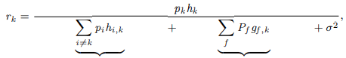

where pk and pi are the transmit power of FU k and FU i, respectively. hk is the channel gain from FU k to the FBS. hi,k is the interference channel gain from FU i. Pf and gf ,k denote the transmit power of MU f and the interference channel gain from MU f. σ2 is the background noise power.

Accordingly, the data rate of FU k is Rk = log2(1 + rk ). From (1), pk and pi are coupled in rk , so that the sum rate k Rk is non-convex. If the objective function becomes the total power minimization, the formulated objective function is convex. If the objective function becomes the EE maximization (e.g., k Rk k pk +pc ), it belongs to a fractional programming (FP) problem. Where pc is the circuit power consumption. Thus, we require to convert it into a convex form. As a result, for different RA problems, it is difficult to use one common approach to deal with it. Moreover, for different transmission modes (uplink/downlink), the maximum transmit power constraint is different. Under an uplink mode, the transmit power of FU is limited by its own peak power constraint. However, for a downlink mode, the allocated power from the FBS to each FU is limited by the sum power constraint at the BS.

RA Models in OFDMA-Based HetNets In order to show the features of RA models in OFDMA based HetNets, we use a downlink OFDMA-based heterogeneous macro-femto network as an example. The number of MUs and FUs is the same as traditional HetNets. The total bandwidth is divided into N orthogonal subcarriers denoted by ∀n ∈ {1, 2,..., N }. According to the orthogonality of adjacent subcarriers, the interference signal among two different subcarriers can be ignored [50]. Define αn,k as the subcar rier assignment factor, and αn,k ∈ {0, 1}, k αn,k ≤ 1, ∀n. When αn,k = 1 means subcarrier n is assigned to FU k, and αn,k = 0 otherwise. Moreover, each subcarrier is allocated to at most one FU at a time. Then, the received SINR of FU k on the subcarrier n is

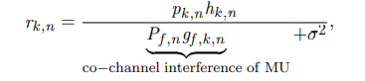

where pk,n and hk,n denote the allocated power and channel gain from the FBS to FU k on subcarrier n, respectively. Pf ,n and gf ,k,n denote the allocated power from the MBS to MU f and interference channel gain from the MBS to FU k on subcarrier n, respectively. Accordingly, the data rate of FU k is ROFDMA k = n αk,nlog2(1 + rk,n). Thus, the sum rate k ROFDMA k is non-convex due to the integer variable αn,k . As a result, the differences of the RA problems in traditional HetNets and OFDMA-based HetNets are

(i) If the subcarrier assignment is completed, the sum-rate maximization of FUs in OFDMA-based HetNets is convex due to no interference power from other FUs, while a sum-rate maximization objective is non-convex in traditional HetNets; (ii) The subcarrier allocation (SA) and the inter-tier interference in SINR expression are also different.

RA Models in NOMA-Based HetNets Since multiple users can share the same subchannels by using the NOMA technique, the co-channel interference becomes a key challenge by comparing with the above two networks. Consider a downlink multiuser NOMA-based HetNet with K FUs, the channel gains of FUs satisfy hNOMA 1 ≤···≤ hNOMA K . Based on SIC, the transmit power of FU satisfies pNOMA 1 ≥···≥ pNOMA K [60]. For any j > k, the SINR of the k-th FU under the power-domain NOMA becomes

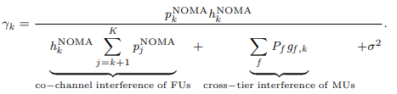

Compared (1) with (3), the difference of SINR is the interference item from FUs in NOMA-based HetNets. The user with a strong channel can cancel the co-channel interference from other FUs with bad channels. Moreover, due to the feature of NOMA, the RA problems of NOMA-based HetNets not only must consider PA, but also need to consider the fairness of different users [61]. The RA problem in NOMA-based HetNets also needs to consider the decoding constraint for ensuring the successful decoding order.

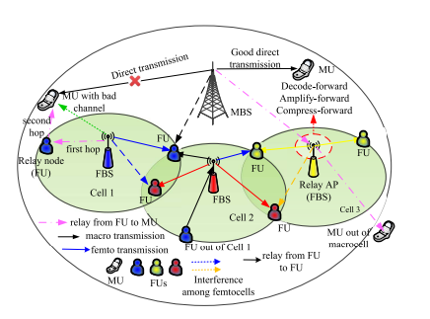

RA Models in Relay-Based HetNets In relay-based HetNets, RA problems with relays are completely different from the networks without relays. From Fig. 7, RA models are different under different relay modes, such as decode-forward (DF), amplify-forward (AF), and compress-forward (CF) [62]. Consider an uplink single user heterogeneous relay network, define the MU and the MBS as the source node and the destination node, respectively. The FBS as a relay node helps the data transmission between the source node and the destination. Therefore, the transmission rates of source-relay (RS→R), source-destination (RS→D), and relay-destination (RR→D) are RS→R = log2(1 + pShS→R σ2 ), RS→D = log2(1 + pShS→D σ2 ), and RR→D = log2(1 + pRhR→D σ2 ), respectively. Where pS and pR are the transmit power of source node and relay node, respectively. hS→D, hS→R, and hR→D are the channel gains of direct link, source-relay link, and relay-destination link. Therefore, the achievable rate under the two-hop relay protocol [63] is

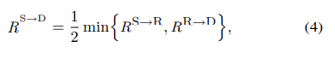

Based on (4), if RS→D ≥ RS→D , the channel gain of direct link is better than that of relay link, we choose the direct link for data transmission. Otherwise, we choose the relay link. In particular, the RA in relay-based HetNets optimizes the transmit power of the source node and relay transmitter. Additionally, the QoS requirements of two hops and relay selection are considered at the same time. Moreover, the relay network needs to compare the transmission quality of the direct link and the relay link.

The challenges of RA problems in H-CRANs are not only PA and UA, but also the task offloading of BBU, resource block (RB). Consider a downlink H-CRAN with one macrocell with F MUs and K RRHs with M remote user equipments (RUEs). Each RRH is connected to the BBU pool via the fronthaul links. Let ∀k ∈ {1,..., K} and ∀j, m ∈ {1,..., M } denote the sets of RRHs and RUEs, respectively. Define the set of RRHs connected to the BBU pool by the wired fronthaul links as K1 = {1,..., K1}, and the set of RRHs connected to the BBU pool by the wireless links as K2 = {K1+1,..., K}. If RUE m is associated in RRH k, αm,k = 1, otherwise αm,k = 0. The received SINR for RUE m accessing RRH k is given by



where pm,k and hm,k are the transmit power and channel gain of RUE m in RRH k. PM f denotes the allocated power from MBS to MU f. gj,m,k is the channel gain of the inter-tier link to RUE m. gM f ,m is the channel gain of the cross-tier link. σ2 is the AWGN power. Similarly, the received SINR of MU f is γf = PM f hf km αm,k pm,k gm,k,f +σ2 , where hf is the channel gain from the MBS to MU f. gm,k,f denotes the interference channel gain from link m to MU f. Thus, the individual capacity constraint of each RRH satisfies

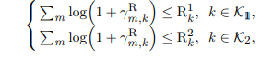

where R1 k and R2 k are the different capacity limitation of wired and wireless transmissions between the RRHs and BBU pool. As a result, the RA models in H-CRANs not only require to consider PA and UA, but also need to consider the constraint of the limited transmission capacity in (6), which is the main difference from the other RA model.

In addition to the required QoS and spectrum sharing, fairness among different users is another important index in wireless RA problems [64]. For example, since the transmission distances between the SUs and the SBSs are different, the transmission path also differs. As a result, this phenomenon will lead to unfairness. Fairness-based RA not only considers the interference power to the primary macro network but also fully utilizes the range expansion of small cells. Specifically, the fairness index can be classified into the following four types:

**Max-min fairness:** The objective of the max-min fairness is to maximize the performance (e.g., transmission rate, EE) of the worst-case link. By using max-min fairness, the rate gap among different users can be narrowed, and the potential service outage can be reduced. For example, for the nonuniform distribution scenario of users, the performance of the cell-edge user or the minimum-rate user with a poor radio environment can be improved a lot. As the notations in Section III-A, for any SU k, the max-min fairness utility function is defined as maxpk min∀k Rk (pk ).

**Proportional fairness:** Proportional fairness was firstly proposed in [65] based on changing rate control for elastic transmission of network services. Proportional fairness can obtain a better trade-off between maximum utilities and max-min fairness [66]. For example, in HetNets, for any SU k, the proportional fairness transmission rate is denoted by Rk (pk ) Rk+1(pk+1) = λk λk+1 , ∀k (i.e., R1 : R2 : ··· : Rk = λ1 : λ2 : ··· : λK ). Where Rk and λk are the transmission rate and the proportional fairness weighted factor at the k-th SU, respectively. The proportional fairness factor is the predetermined value ahead of time according to the priority of users.

**DISADVANTAGES**

In traditional multi-user (MU) MIMO systems, fully digital (FD) precoding is the typical approach to adjust the amplitudes and phases of the transmitted signals in order to achieve optimum beamforming. However, in a massive MIMO configuration, FD approach would result in a significant computational and hardware burden, since the number of radio frequency (RF) chains is equal to the number of antennas.

**CHAPTER-IV**

**PROPOSED METHOD**

**ANTENNA DESIGN** Fig. 1 depicts the suggested adaptive beam former construction. A baseband digital precoder FBB on the transmitter side converts NS data streams into NRF BS outputs. The diversity combining transmission method is taken for granted for the remainder of this study, therefore Ns = Kb, where the latter value denotes the number of MSs in the b th BS (1≤ b ≤ B).

The example of spatial multiplexing transmission may, however, be simply added to using our strategy. FBB matrix has dimensions Kb x v, and each of the v RF chains is linked to a portion of the total transmitting antennas of a specific vertical array of length w, as shown in Fig. 1. To produce a beam in accordance with the CSI at BSs, each of the several transmitting antennas for each RF subset is turned on or off. Less complicated hardware and algorithms are provided by this on-off analog beamforming.

Each of the v RF chains in this structure is designed to cover a particular angular space, even though it is a PC-HBF architectural case [11]. As a result, it is unnecessary to link each RF chain to each transmitting antenna. Each RF chain, as shown in Fig. 2, consists essentially of a vertical array of crossed dipole (CD) antennas that have been tuned to resonate at the 28 GHz mmWave frequency.

In addition, a=360/v creates a circular array by evenly spacing the v RF chains on a ring. The two identical but orthogonal (450) radiating half-wave dipoles that make up each CD antenna are specifically shown in Fig. 3. At this point, it should be mentioned that a dual polarization (DP) antenna system has been formed by applying an input voltage of 1V and a phase difference of 00 between the half-wave dipoles. This is achieved due to the utilization of separate feeding ports. Such type of feeding topologies facilitates the development of the current beamforming-oriented configuration for 5G applications [29]-[32].

Each of the vertical crossing dipoles is spaced /2 away from the other, where is the carrier wavelength, to increase the gain in the horizontal plane as previously described. In order to produce unidirectional DP radiation, all of the radiating components are additionally positioned at a distance of /4 above a perfect electric conductor (PEC, reflector), which results in an additional gain boost. Last but not least, [33]-[35] on the right side of Fig. 3 (profile of the CD), the breadth and spacing between the two radiating components are of the order of /100.

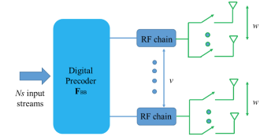

Fig: Proposed adaptive beam forming structure

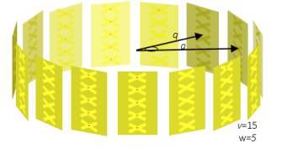

Fig: An example of circular array.

The Method of Moments (MoM) was used to conduct an electromagnetic analysis of the circular array shown in Fig. 2 [36]. In this situation, the parameters w, q, v, and a uniquely describe each research. Note that the current simulations have taken into account the significant effects of mutual coupling among all radiating elements (vw2). In order to achieve this, our 3D computational model has taken into account changes in the radiation pattern and input impedance of the array [37].

First, two distinct sets of simulations will be shown. The first is distinguished by having a fixed grid of beams (FGoB) that are stimulated by a fixed array configuration, which is distinguished by certain q, w, v, and a parameters. The beamforming method is determined by the azimuth radiation patterns produced by the second set of simulations, in contrast, where q and v values are fixed while a and w values are flexible [38]–[40].

PROPOSED APPROACH:

The studied adaptive beamforming approach is described in Table I. In this context, the set denotes the active radiating elements of the array geometry deployed in the bth BS and  the corresponding angles of the generated adaptive beams (notation a:b indicates all elements from a to b with step 1). Moreover, each entry of  (indicating the channel matrix of the k th MS relevant to its serving sector for the s th PRB) is calculated according to (2). In addition, x represents the eigenvector corresponding to the maximum eigenvalue of matrix , SNRk is the signal to noise ratio of the k th MS with respect to all available PRBs of the b th BS (i.e., b ) and  represent the total losses and the channel gain, respectively, of the k th MS relevant to the s th PRB. Finally, the minimum required SNR for acceptable QoS and the thermal noise level at the receiver are denoted by SNRth and Io, respectively. Note that during subcarrier allocation (line 3), function sort(SNRk,Rk) sorts the values in vector matrix SNRk in descending order and returns the first Rk sorted values as well as the corresponding indexes (assigned to set k ).

An arbitrary BS is assumed to use a FGoB in the initial state, with three active sectors separated by 120 degrees spatially. In order to do this, the deployed geometry is specified in accordance with the angle of the first MS that is utilized by this BS. In order to achieve the required 120o spacing in the deployed beams, two more arrays—vo + [v/3] and vo+2[v/3]—must also be activated in this scenario, assuming that the vertical array vo is already active. When a possible (new) MS seeks to join the network and requests Rk PRBs, it is checked to see if the geometry already in place can supply the minimal amount of transmission power necessary for good QoS without experiencing a power loss.

According to the angular position of the prospective new MS, this is accomplished by activating a different vertical array (see lines 11–14 in Table I and the blue arrows pointing to the neighboring vertical arrays).

Note that in this instance, the whole array's radiating components are turned on. However, if there is a power loss in at least one of the MSs previously covered by this BS, all radiating elements in the first vertical arrays (specified in line 1) can be activated, creating a grid of beams with higher gain.

In each of the aforementioned situations where the antenna radiation pattern is altered, it is determined if the proposed changes to the radiation diagram would cause a link outage for another MS that the bth BS already serves (for example, lines 16 and 21). The reject flag (rf) is set to 1 and the procedure is repeated for the next candidate MS if this is the case, even though all radiating elements for each vertical array are active (Fig. 5(h)). Otherwise, updates are made to corresponding sets (i.e., b and b).

**COMPLEXITY-CONVERGENCE**

According to [26], for an MU downlink system with NRF RF chains and Nt transmitting antennas, the computational complexity of optimum antenna partitioning will be given by



This complexity can be significant, even for a small number of RF chains and antennas. In [26], the complexity of the proposed subarray partitioning algorithm is reduced to NRF×Nt. In [28], the complexity of various analogic beamforming algorithms is evaluated, which is proved to be of the order of O(Nt 3 ).

The studied adaptive beamforming approach is described in Table I. In this context, the set b denotes the active radiating elements of the array geometry deployed in the bth BS and b the corresponding angles of the generated adaptive beams (notation a:b indicates all elements from a to b with step 1). Moreover, each entry of Hk k s ,sec( ), (indicating the channel matrix of the kth MS relevant to its serving sector for the sth PRB) is calculated according to (2). In addition, x represents the eigenvector corresponding to the maximum eigenvalue of matrix H H H k k s k k s ,sec( ), ,sec( ), SNRk is the signal to noise ratio of the kth MS with respect to all available PRBs of the bth BS (i.e.,b) and TLk,sec(k),s, CGk,s represent the total losses and the channel gain, respectively, of the kth MS relevant to the s th PRB. Finally, the minimum required SNR for acceptable QoS and the thermal noise level at the receiver are denoted by SNRth and Io, respectively. Note that during subcarrier allocation (line 3), function sort(SNRk,Rk) sorts the values in vector matrix SNRk in descending order and returns the first Rk sorted values as well as the corresponding indexes (assigned to set k).

**FIXED GRID OF BEAMS**

The first set of simulation results is presented in Figs. 6-8 for the considered antenna geometries of Fig.4 (FGoB). In all figures, cumulative distribution function (CDF) curves have been plotted versus each of the considered KPIs of Section II. Since adaptive modulation and coding per subcarrier is outside the scope of our study, we consider two distinct values for the requested transmission rate, common for all MSs (i.e., Rk = R), which is can be satisfied with a proper assignment of PRBs and modulation order per PRB. In this context, in all simulation scenarios either 5 or 15 PRBs can be allocated to a potential MS, thus equivalent bit rates of 7.2/21.6 Mbps can be supported (i.e., the product of the assigned PRBs per MS, the subcarriers per PRB, the subcarrier spacing, as well the transmitted bits per subcarrier as defined by the modulation.

Moreover, wireless orientations with two tiers of cells around the central cell have been considered. All simulation parameters are summarized in Table II, which are aligned with the majority of related works in [44]. Finally, in each figure legend, notation (v,w,R) has been considered. Since all vertical arrays are activated, the term active beams will be used as well throughout the rest of this subsection to indicate the number of generated beams per BS.

Total Throughput = assigned_PRBs_perMS*Nu*PRB

Where,

Throughput = Data that can be transferred by the network

assigned_PRBs_perMS = assigned Physical Resource Blocks per Mobile Station or user

PRB = Physical Resource Blocks

Pt = Nu*Max_tx_Power_BSperMS

Where,

Pt = Total Transmission Power

Nu = Number of users

Max_tx_Power_BSperMS = Maximum Transmission Power of Base Station that can be consumed per Mobile Station or user

**ADAPTIVE GRID OF BEAMS**

In the second set of simulation results (Figs. 9-12), the sproposed adaptive beamforming approach has been considered. To this end, the geometry of Fig. 5 is deployed in each one of the active BSs. All output metrics are compared against the FGoB scenario, where three beams per BS at {0o,120o,240o} are generated. In Fig. 12, an additional KPI is taken into consideration: the total number of radiating elements per MC simulation in the adaptive grid of beams (AGoB) and FGoB scenarios. In all figures, notation (v,w,R) is used when considering the FGoB (also depicted as FB) while notation (v,w,wo,R) is used for the AGoB (also depicted as AB). Throughout the rest of this analysis, unless otherwise specified, all KPIs are compared with respect to their mean values. As it can be observed from Fig. 9, there are no significant throughput variations in the AGoB and FGoB cases for all the considered MIMO configurations. However, as it is evident from Fig. 12, a significant reduction in the total number of radiating elements can be achieved. Considering 5 PRBs per MS and wo = 3 in the AGoB scenario, a mean total throughput of 2245 Mbps can be supported, as in the FGoB case. However, 190 radiating elements are now activated versus 285 elements in the FGoB case. This value is further increased to 230, when wo = 4. Nevertheless, this increment is combined with reduced transmission power compared to the wo = 3 case.

Total Throughput = assigned_PRBs_perMS*Nu*PRB

Where,

Throughput = Data that can be transferred by the network

assigned_PRBs_perMS = assigned Physical Resource Blocks per Mobile Station or user

Nu = Number of users

PRB = Physical Resource Blocks

In particular, corresponding mean values are (17/10) W, respectively, for the aforementioned scenarios (wo = 3,4). In the case of 15 PRBs per MS, a total network throughput of 1700 Mbps can be supported. Active radiating elements are now 182/223/277 for the considered three cases (AGoB with wo = 3,4, respectively, and FGoB) while corresponding transmission power is 9/6/4.8 W. In addition, when wo = 4 then BP can be reduced compared to the FGoB approach: for 5 PRBs per MS corresponding values are 0.75%/0.5% for the FGoB/AGoB cases, respectively, and 3.8%/2.5% when considering 15 PRBs per MS.

Pt = Nu*Max_tx_Power_BSperMS

Where,

Pt = Total Transmission Power

Nu = Number of users

Max_tx_Power_BSperMS = Maximum Transmission Power of Base Station that can be consumed per Mobile Station or user.

**CHAPTER 6**

**TOOL CONTENT**

**INTRODUCTION TO MATLAB**

**What Is MATLAB?**

MATLAB is an elite dialect for specialized registering. It incorporates calculation, representation, and programming in an easy to-utilize condition wherein issues and preparations are communicated in herbal numerical documentation. Run of the mill utilizes comprise

• Math and calculation

• Algorithm advancement

• Data obtaining

• Modeling, re-enactment, and prototyping

• Data examination, investigation, and representation

• Scientific and designing illustrations

• Application advancement, including graphical UI building

MATLAB is an intuitive framework whose important statistics aspect is an show off that does not require dimensioning. This allows you to tackle several specialized processing issues, particularly those with framework and vector info, in a small quantity of the time it'd take to compose a program in a scalar non intuitive dialect, as an instance, C or FORTRAN.

The call MATLAB stays for grid studies facility. MATLAB changed into first of all composed to present easy access to framework programming created by way of the LINPACK and EISPACK ventures. Today, MATLAB motors fuse the LAPACK and BLAS libraries, inserting the cutting side in programming for network calculation.

MATLAB has advanced over a time of years with contribution from several customers. In university situations, it's far the usual academic apparatus for early on and propelled guides in mathematics, designing, and science. In enterprise, MATLAB is the tool of choice for excessive-profitability studies, advancement, and exam.

MATLAB highlights a collection of more utility-specific arrangements known as tool booths. Important to most clients of MATLAB, device kits permit you to learnandapply particular innovation. Tool compartments are exhaustive accumulations of MATLAB capacities (M-records) that reach out the MATLAB condition to take care of precise training of problems. Territories in which tool stash are reachable include flag coping with, manipulate frameworks, neural structures, fluffy reason, wavelets, pastime, and severa others.

**The MATLAB System:**

The MATLAB system consists of five main parts.

**Development Environment:**

 This is the set of tools and centres that help you operate MATLAB features and files. Many of that gear are graphical person interfaces. It includes the MATLAB desktop and Command Window, a command history, an editor and debugger, and browsers for viewing assist, the workspace, files, and the hunt direction.

**The MATLAB Mathematical Function:**

This is a great collection of computational algorithms ranging from standard capabilities like sum, sine, cosine, and complex arithmetic, to extra sophisticated features like matrix inverse, matrix eigen values, Bessel functions, and speedy Fourier transforms.

**The MATLAB Language:**

This is a high-level matrix/array language with control flow statements, functions, data structures, input/output, and object-oriented programming features. It allows both "programming in the small" to rapidly create quick and dirty throw-away programs, and "programming in the large" to create complete large and complex application programs.

**Graphics:**

MATLAB has considerable centres for displaying vectors and matrices as graphs, as well as annotating and printing those graphs. It consists of high-stage functions for 2-dimensional and 3-dimensional records visualization, photograph processing, animation, and presentation graphics. It also consists of low-stage capabilities that will let you absolutely customise the appearance of graphics as well as to construct complete graphical person interfaces for your MATLAB programs.

**The MATLAB Application Program Interface (API):**

This is a library that allows you to put in writing C and Fortran applications that have interaction with MATLAB. It consists of facilities for calling workouts from MATLAB (dynamic linking), calling MATLAB as a computational engine, and for studying and writing MAT-documents.

**7.2 MATLAB WORKING ENVIRONMENT:**

**MATLAB DESKTOP:**

Matlab Desktop is the principle Matlab application window. The desktop consists of five sub windows, the summon window, the workspace program, the existing catalog window, the order records window, and at the least one figure home windows, which can be proven simply while the consumer suggests a sensible.

The order window is the area the customer sorts MATLAB orders and expressions at the initiate (>>) and wherein the yield of these fees is shown. MATLAB characterizes the workspace because the association of factors that the customer makes in a work session. The workspace software demonstrates these elements and some statistics approximately them. Double tapping on a variable within the workspace application dispatches the Array Editor, which may be applied to get data and salary instances modify sure homes of the variable.

The present Directory tab over the workspace tab demonstrates the substance of the existing registry, whose way is seemed within the present index window. 1For case, within the windows running framework the manner may be as consistent with the subsequent: C:MATLABWork, demonstrating that registry "paintings" is a subdirectory of the primary catalog "MATLAB", which is delivered in pressure C. Tapping on the bolt inside the present index window demonstrates a rundown of as of past due utilized approaches. Tapping at the seize to one aspect of the window enables the client to exchange the existing catalog.

MATLAB utilizes an inquiry way to discover M-data and different MATLAB related documents, which might be sort out in catalogs within the PC file framework. Any file keep strolling in MATLAB must dwell inside the ebb and go with the flow registry or in an index that is on are trying to find manner. Of direction, the statistics supplied with MATLAB and math works device kits are included into the inquiry way. The least stressful method to look which indexes are at the inquiry manner. The handiest method to peer which catalogs are soon the quest way, or to encompass or regulate an inquiry manner, is to pick set manner from the File menu the computer, and after that utilization the set way exchange container. It is exquisite exercise to add any typically utilized catalogs to the pursuit way to hold a strategic distance from again and again having the exchange the existing index.

The Command History Window contains a record of the orders a client has entered in the charge window, including both present and past MATLAB sessions. Already entered MATLAB orders can be chosen and re-executed from the charge history window by right

tapping on a summon or arrangement of orders. This activity dispatches a menu from which to choose different choices notwithstanding executing the orders. This is helpful to choose different choices notwithstanding executing the summons. This is a valuable component while trying different things with different orders in a work session

**Using the MATLAB Editor to create M-Files:**

The MATLAB manager is both a word processor unique for making M-statistics and a graphical MATLAB debugger. The proofreader can display up in a window without everybody else, or it could be a sub window in the laptop. M-facts are intended by means of the expansion .M, as in pixelup.M. The MATLAB editorial manager window has various draw down menus for errands, for instance, sparing, seeing, and troubleshooting documents. Since it plays out a few basic checks and furthermore utilizes shading to separate between exclusive additives of code, this content device is suggested as the equipment of selection for composing and changing M-capacities. To open the proofreader, sort regulate at the incite opens the M-report filename.M in a supervisor window, organized for altering. As referred to before, the record has to be inside the momentum catalog, or in an index within the pursuit manner.

**Getting Help:**

The important technique to get help on line is to utilize the MATLAB assist application, opened as a exclusive window both via tapping at the query mark image at the computing device toolbar, or by using writing help program on the provoke within the order window. The help Browser is an internet application coordinated into the MATLAB computing device that shows a Hypertext Markup Language (HTML) statistics. The Help Browser contains of two sheets, the assistance pilot sheet, used to find out data, and the show sheet, used to look the statistics. Clear as crystal tabs aside from pilot sheet are applied to play out a pursuit. Second, within the motion pictures taken via transferring camera setup, the state of affairs becomes extra complex because the heritage may additionally exchange by using shifting shot, we cannot tune item motion exactly inside the sum of distinction map. Therefore, in this situation, the purpose is executed through reusing the previous seam and applying it to the cutting-edge body. In order to discover the seams, we use the preceding seam from previous body to look the modern-day seam in contemporary frame. our method is using a seam computed in frame1 (in crimson) to go looking a comparable seam in frame2. For the pixels close by the area of previous seam, we decide how a lot the selected pixel might vary from the pixel of preceding seam. We use difference of the 2 pixels as the degree of temporal coherence. If the distinction value of first seam pixel is over the threshold, we can keep to go looking the next seam pixel on three feasible pixels (in yellow, blue and brown) in subsequent row, until we discover 5 consecutive pixels that also exceed the threshold.

When we can't search the matching seam, we recalculate the energy for a new seam. We assume a seam 𝑆l-1 has been calculated inside the previous body, and a seam must be calculated for the contemporary frame. For preserving the temporal coherence, we want to make a new seam close to the previous seam with the identical index. We use the distinction among preceding seam and all pixels at the current body as the measure

Thus we upload temporal coherence price Tc(i,j) to the strength map earlier than calculating a seam 𝑆L. The price Tc is zero while the body pixels have the equal fee as previous seam pixels. Using our temporal coherence price, we will calculate the seam which has least electricity and is more close to the preceding seam in previous frame. Consequently, we will decrease the jittery artifacts inside the films.

**COMMUNICATION:**

Communications System Toolbox™ offers algorithms and gear for the layout, simulation, and analysis of communications systems. These capabilities are furnished as MATLAB ® features, MATLAB System gadgets™, and Simulink ® blocks. The machine toolbox includes algorithms for source coding, channel coding, interleaving, modulation, equalization, synchronization, and channel modeling. Tools are supplied for bit blunders charge evaluation, producing eye and constellation diagrams, and visualizing channel characteristics. The machine toolbox additionally provides adaptive algorithms that allow you to version dynamic communications structures that use OFDM, OFDMA, and MIMO techniques. Algorithms support fixed-point facts arithmetic and C or HDL code era.

**Key Features**

▪ Algorithms for designing the physical layer of communications systems, which includes supply coding, channel coding, interleaving, modulation, channel fashions, MIMO, equalization, and synchronization

▪ GPU-enabled System objects for computationally intensive algorithms together with Turbo, LDPC, and Viterbi decoders

▪ Interactive visualization equipment, consisting of eye diagrams, constellations, and channel scattering capabilities

▪ Graphical tool for evaluating the simulated bit mistakes rate of a machine with analytical outcomes

▪ Channel models, consisting of AWGN, Multipath Rayleigh Fading, Rician Fading, MIMO Multipath Fading, and

LTE MIMO Multipath Fading

▪ Basic RF impairments, along with nonlinearity, section noise, thermal noise, and section and frequency offsets

▪ Algorithms available as MATLAB features, MATLAB System objects, and Simulink blocks

▪ Support for fixed-point modeling and C and HDL code technology

**System Design, Characterization, and Visualization:**

The layout and simulation of a communications gadget requires analyzing its reaction to the noise and interference inherent in real-world environments, reading its behavior the usage of graphical and quantitative manner, and determining whether the resulting overall performance meets requirements of acceptability. Communications System Toolbox implements a selection of obligations for communications machine layout and simulation. Many of the functions, System objects™, and blocks inside the device toolbox perform computations associated with a specific thing of a communications gadget, consisting of a demodulator or equalizer. Other talents are designed for visualization or evaluation.

**System Characterization**

The system toolbox offers several standard methods for quantitatively characterizing system performance:

▪ Bit error rate (BER) computations

▪ Adjacent channel power ratio (ACPR) measurements

▪ Error vector magnitude (EVM) measurements

▪ Modulation error ratio (MER) measurements

Because BER computations are fundamental to the characterization of any communications system, the system toolbox provides the following tools and capabilities for configuring BER test scenarios and accelerating BER simulations:

**BER tool**— A graphical user interface that enables you to analyze BER performance of communications systems. You can analyze performance via a simulation-based, semi analytic, or theoretical approach.

**Error Rate Test Console** — A MATLAB object that runs simulations for communications systems to measure error rate performance. It supports user-specified test points and generation of parametric performance plots and surfaces. Accelerated performance can be realized when running on a multi core computing platform.

**Multi core and GPU acceleration** — A capability provided by Parallel Computing Toolbox™ that enables you to accelerate simulation performance using multi core and GPU hardware within your computer.

**Distributed computing and cloud computing support** — Capabilities provided by Parallel Computing Toolbox and MATLAB Distributed Computing Server™ that enable you to leverage the computing power of your server farms and the Amazon EC2 Web service. Performance Visualization. The system toolbox provides the following capabilities for visualizing system performance:

**Channel visualization tool** — For visualizing the characteristics of a fading channel

**Eye diagrams and signal constellation scatter plots** — for a qualitative, visual understanding of system behavior that enables you to make initial design decisions

**Signal trajectory plots** — for a continuous picture of the signal’s trajectory between decision points

**BER plots** — for visualizing quantitative BER performance of a design candidate, parameterized by metrics such as SNR and fixed-point word size

**Analog and Digital Modulation**

Analog and digital modulation strategies encode the facts circulation into a sign this is appropriate for transmission. Communications System Toolbox presents some of modulation and corresponding demodulation abilities. These talents are available as MATLAB features and gadgets, MATLAB System Modulation sorts provided by the toolbox are:

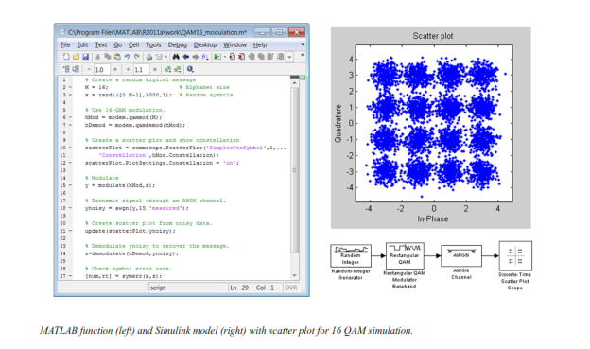

**Source and Channel Coding**

Communications System Toolbox affords source and channel coding talents that can help you develop and compare communications architectures fast, enabling you to discover what-if eventualities and avoid the need to create coding competencies from scratch.

**Source Coding**

Source coding, also referred to as quantization or signal formatting, is a manner of processing facts a good way to lessen redundancy or prepare it for later processing. The system toolbox offers a diffusion of styles of algorithms for imposing source coding and interpreting, inclusive of:

▪ Quantizing

▪ Companding (*µ*-law and A-law)

▪ Differential pulse code modulation (DPCM)

▪ Huffman coding

▪ Arithmetic coding

**Channel Coding**

▪ orthogonal area-time block code (OSTBC) (encoder and decoder for MIMO channels)

▪ Turbo encoder and decoder examples

The gadget toolbox offers application functions for developing your personal channel coding. You can create generator polynomials and coefficients and syndrome deciphering tables, in addition to product parity-take a look at and generator matrices.

The system toolbox additionally presents block and convolutional interleaving and deinters leaving functions to reduce facts errors as a result of burst mistakes in a conversation machine:

**Block,** including General block interleaver, algebraic interleaver, helical scan interleaver, matrix interleaver, and random interleaver.

**Convolutional,** including General multiplexed interleaver, convolutional interleaver, and helical interleaver

**Channel Modeling and RF Impairments**

Channel Modeling

Communications System Toolbox provides algorithms and tools for modeling noise, fading, interference, and different distortions which might be commonly found in communications channels. The system toolbox supports the subsequent styles of channels:

▪ Additive white Gaussian noise (AWGN)

▪ Multiple-enter multiple-output (MIMO) fading

▪ Single-enter single-output (SISO), Rayleigh, and Rician fading

▪ Binary symmetric

A MATLAB channel object provides a concise, configurable implementation of channel models, enabling you to specify parameters such as:

▪ Path delays

▪ Average path gains

▪ Maximum Doppler shifts

▪ K-Factor for Rician fading channels

▪ Doppler spectrum parameters

For MIMO systems, the MATLAB MIMO channel object expands these parameters to also include:

▪ Number of transmit antennas (up to 8)

▪ Number of receive antennas (up to 8)

▪ Transmit correlation matrix

▪ Receive correlation matrix

To combat the effects noise and channel corruption, the system toolbox provides block and convolutional coding and decoding techniques to implement error detection and correction. For simple error detection with no inherent correction, a cyclic redundancy check capability is also available. Channel coding capabilities provided by the system toolbox include:

▪ BCH encoder and decoder

▪ Reed-Solomon encoder and decoder

▪ LDPC encoder and decoder

▪ Convolutional encoder and Viterbi decoder

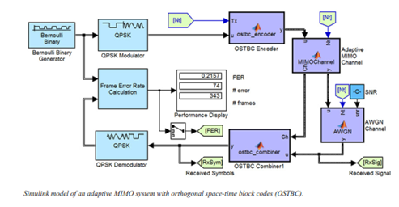

**RF Impairments**

To model the effects of a non-ideal RF front end, you can introduce the following impairments into your communications system, enabling you to explore and characterize performance with real-world effects:

▪ Memory less nonlinearity

▪ Phase and frequency offset

▪ Phase noise

▪ Thermal noise

You can include more complex RF impairments and RF circuit models in your design using SimRF™.

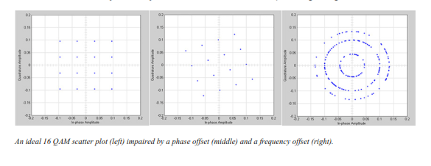

**Equalization and Synchronization**

Communications System Toolbox lets you discover equalization and synchronization strategies. These techniques are usually adaptive in nature and tough to design and symbolize. The machine toolbox affords algorithms and tools that will let you swiftly select the proper approach on your communications machine. Equalization To compare one-of-a-kind techniques to equalization, the device toolbox offers you with adaptive algorithms which include:

▪ LMS

▪ Normalized LMS

▪ Variable step LMS

▪ Signed LMS

▪ MLSE (Viterbi)

▪ RLS

▪ CMA

These adaptive equalizers are available as nonlinear decision feedback equalizer (DFE) implementations and as

Linear (symbol or fractionally spaced) equalizer implementations.

**Synchronization**

The device toolbox provides algorithms for each service segment synchronization and timing phase synchronization. For timing section synchronization, the machine toolbox presents a MATLAB Timing Phase Synchronizer object that offers the following implementation techniques:

▪ Early-late gate timing method

▪ Gardner’s method

▪ Fourth-order nonlinearity method

**Stream Processing in MATLAB and Simulink**

Most verbal exchange structures cope with streaming and frame-primarily based statistics using a aggregate of temporal processing and simultaneous multi frequency and multichannel processing. This form of streaming multidimensional processing can be visible in superior communication architectures consisting of OFDM and MIMO. Communications System Toolbox enables the simulation of advanced communications structures via helping move processing and frame-based simulation in MATLAB and Simulink. In MATLAB, circulate processing is enabled by way of System items™, which use MATLAB objects to symbolize time-based and facts-driven algorithms, sources, and sinks. System objects implicitly manipulate many information of flow processing, including information indexing, buffering, and management of set of rules state. You can mix System gadgets with fashionable MATLAB functions and operators. Most System items have a corresponding Simulink block with the identical abilities. Simulink handles circulation processing implicitly with the aid of coping with the float of information thru the blocks that make up a Simulink model. Simulink is an interactive graphical environment for modeling and simulating dynamic systems that uses hierarchical diagrams to symbolize a machine version. It includes a library of widespread-reason, predefined blocks to represent algorithms, resources, sinks, and device hierarchy.

**Implementing a Communications System**

Fixed-Point Modeling Many communications systems use hardware that requires a fixed-point representation of your design.

Communications System Toolbox supports fixed-point modeling in all relevant blocks and System objects™ with tools that help you configure fixed-point attributes.

Fixed-point support in the system toolbox includes:

* Word sizes from 1 to 128 bits
* Arbitrary binary-point placement
* Overflow handling methods (wrap or saturation)
* Rounding methods: ceiling, convergent, floor, nearest, round, simplest, and zero

Fixed-Point Tool in Simulink Fixed Point™ facilitates the conversion of floating-point data types to fixed point. For configuration of fixed-point properties, the tool tracks overflows and maxima and minima.

**Code Generation**

Once you've got advanced your set of rules or communications device, you can robotically generate C code from it for verification, rapid prototyping, and implementation. Most System gadgets, functions, and blocks in Communications System Toolbox can generate ANSI/ISO C code the use of MATLAB Coder™, Simulink Coder™, or Embedded Coder™. A subset of System gadgets and Simulink blocks also can generate HDL code. To leverage present highbrow belongings, you can choose optimizations for specific processor architectures and integrate legacy C code with the generated code.

You can also generate C code for both floating-point and fixed-point data types.

DSP Proto typing DSPs are used in communication system implementation for verification, rapid prototyping, or final hardware implementation. Using the processor-in-the-loop (PIL) simulation capability found in Embedded Coder, you can verify generated source code and compiled code by running your algorithm’s implementation code on a target processor. FPGA Prototyping

FPGAs are used in communication systems for implementing high-speed signal processing algorithms. Using the FPGA-in-the-loop (FIL) capability found in HDL Verifier™, you can test RTL code in real hardware for any existing HDL code, either manually written or automatically generated HDL code.

**CHAPTER 7**

**RESULTS**

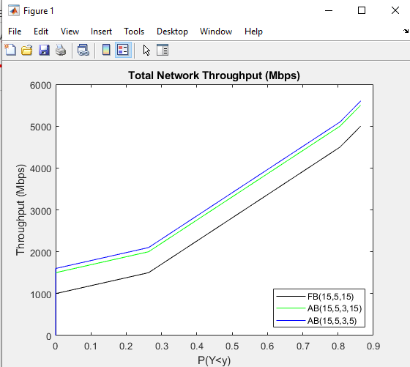

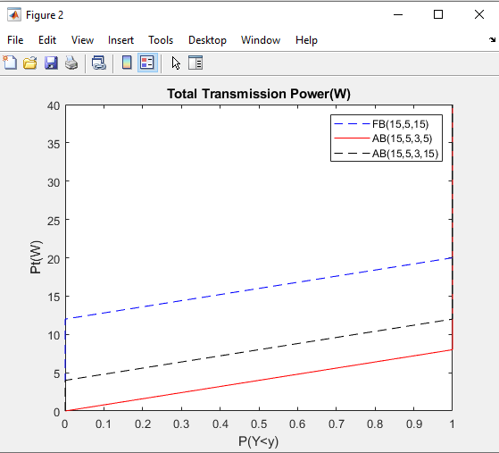

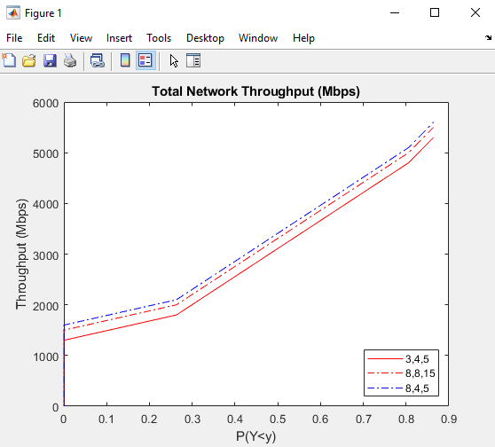

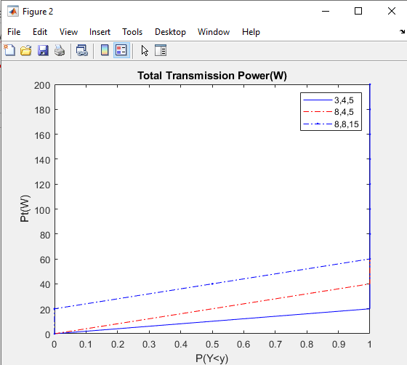

**CHAPTER 8**

**CONCLUSION**

In the context of 5G mmWave cellular networks, the performance of an adaptive hybrid beamforming technique has been assessed. In this situation, each vertical antenna array is connected to a distinct RF chain, and a different set of antenna components is activated to generate the radiation pattern. Each vertical array is a radiating component of a circular array arrangement that enables extensive 360o spatial coverage.

The results show that our adaptive beamforming approach can improve a number of key performance indicators (KPIs) of the cellular orientation, such as total downlink transmission power when all radiating elements per vertical antenna array are activated and blocking probability, even though hardware complexity reduction (expressed via the number of active radiating antenna elements) comes at the expense of increased transmission power. The suggested adaptive beamforming technique is based on flawless CSI at BSs, it should be highlighted at this point.We can, however, readily adapt our method to the situation where the analog stage uses codebook searching to prevent channel estimate of the analog channel with huge dimensions.

**REFERENCES**

1. Y. Xu, G. Gui, H. Gacanin and F. Adachi, “A survey on resource allocation for 5G heterogeneous networks: Current research, future trends, and challenges,” IEEE Commun. Surv. Tutor., vol. 23, no. 2, pp. 668-695, Secondquarter 2021.
2. A. N. Uwaechia and N. M. Mahyuddin, “A comprehensive survey on millimeter wave communications for fifth-generation wireless networks: Feasibility and challenges,” IEEE Access, vol. 8, pp. 62367-62414, Mar. 2020.
3. A. V. Lopez, A. Chervyakov, G. Chance, S. Verma and Y. Tang, “Opportunities and challenges of mmWave NR,” IEEE Wirel. Commun., vol. 26, no. 2, pp. 4-6, Apr. 2019.
4. B. Makki, K. Chitti, A. Behravan and M. -S. Alouini, “A survey of NOMA: Current status and open research challenges,” IEEE OJ-COMS, vol. 1, pp. 179-189, Jan. 2020.
5. N. Nomikos, E. T. Michailidis, P. Trakadas, D. Vouyioukas, T. Zahariadis and I. Krikidis, “Flex-NOMA: Exploiting buffer-aided relay selection for massive connectivity in the 5G uplink,” IEEE Access, vol. 7, pp. 88743-88755, Jul. 2019.
6. E. G. Larsson, O. Edfors, F. Tufvesson and T. L. Marzetta, “Massive MIMO for next generation wireless systems,” IEEE Commun. Mag., vol. 52, no. 2, pp. 186- 195, Feb. 2014.
7. H. Ji et al., “Overview of full-dimension MIMO in LTEadvanced pro,” IEEE Commun. Mag., vol. 55, no. 2, pp. 176-184, Feb. 2017.
8. A. Ghosh, A. Maeder, M. Baker and D. Chandramouli, “5G evolution: A view on 5G cellular technology beyond 3GPP release 15,” IEEE Access, vol. 7, pp. 127639- 127651, Sept. 2019.
9. E. Calvanese Strinati et al., “6G: The next frontier: From holographic messaging to artificial intelligence using subterahertz and visible light communication,” IEEE Veh. Technol. Mag., vol. 14, no. 3, pp. 42-50, Sept. 2019.
10. P. Schulz et al., “Latency critical IoT applications in 5G: Perspective on the design of radio interface and network architecture,” IEEE Commun. Mag., vol. 55, no. 2, pp. 70-78, Feb. 2017